SDEV 200-50P
Chad Swift
Module 8 – Final Project

UML:
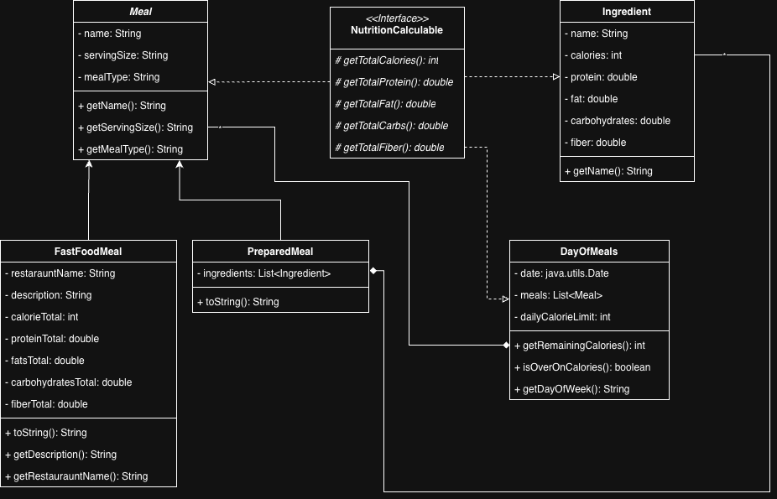

Code:
https://github.com/chad-swift/SDEV200-FinalProject

Testing Screenshots:

Opening screen:
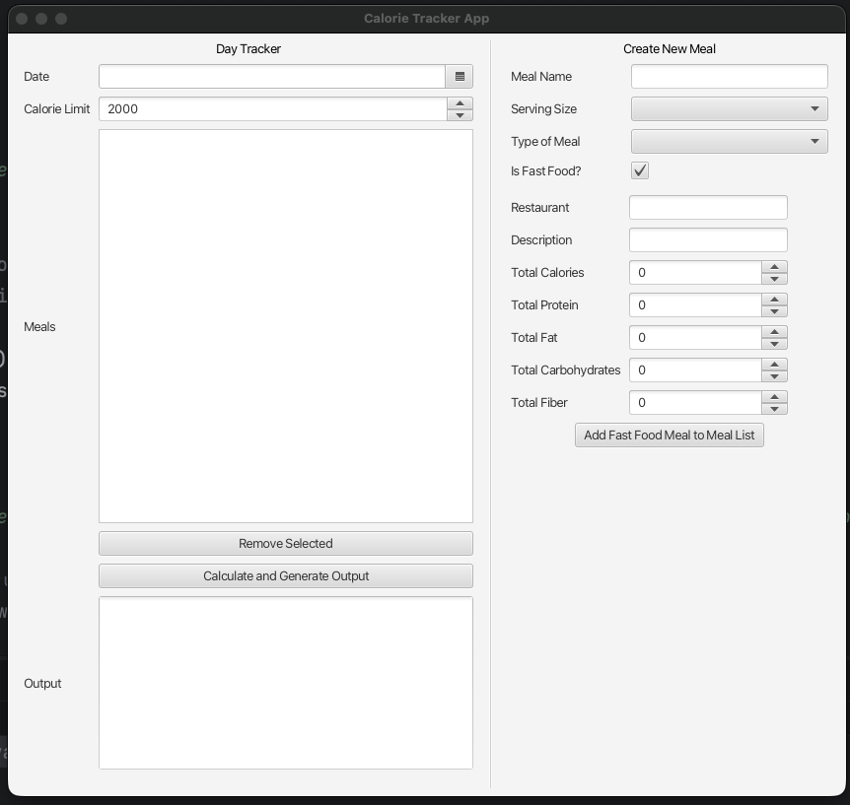

Attempting to type in date box
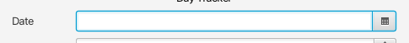
No result, the field is not editable
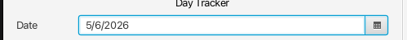
Date box must be used with date picker

Attempting to type in Calorie Limit box
No result, Calorie Limit box is not editable. Spinner must be interacted with the arrows, will raise and lower calorie limit by 100 calorie increments:
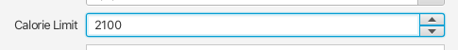

Attempt to use Remove Selected Button with no items added to Meals list:
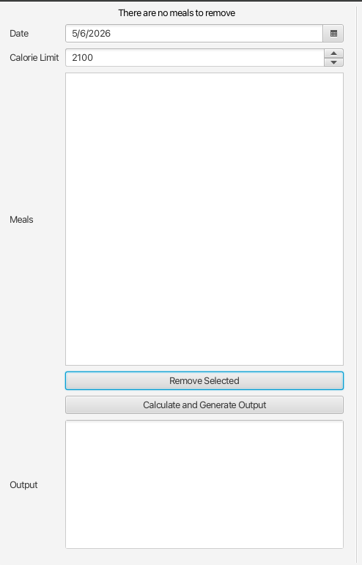
Result: No Exception thrown and section header changes to error message:


Attempt to use Remove Selected button with meals in list but no meal selected
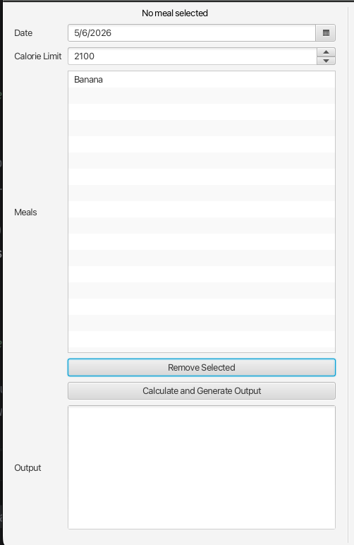
Result: No Exception thrown but section header will update to error message:
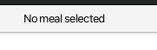

Normal usage of Remove Selected Button to remove item from Meals list
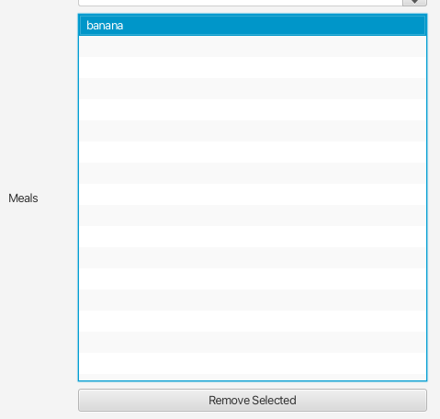
result: No exception thrown, meal is removed from the list
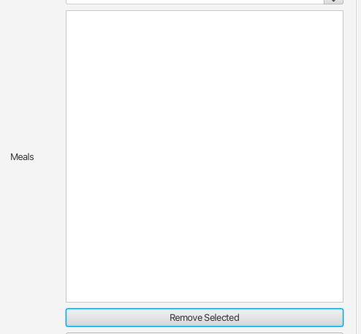

Attempt to run the Calculate and Generate Output button with no meals in the list
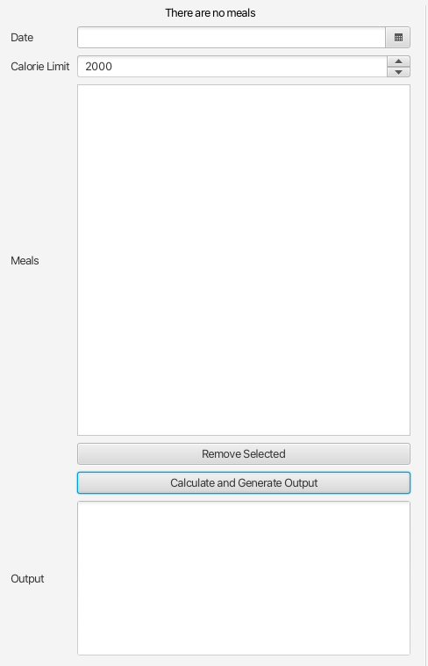
Result: No Exception thrown, section header changes to output message
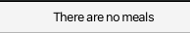

Attempt to run Calculate and Generate Output button with meal added but date is blank
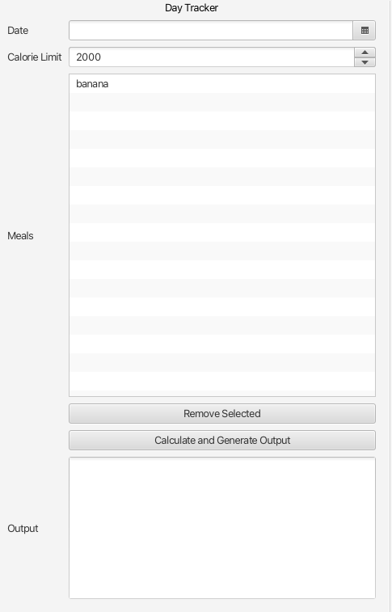
Result: No Exception is thrown, top section header is changed to show error:
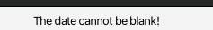

Calculate and Generate Output button is ran with all fields filled out and at least one meal added
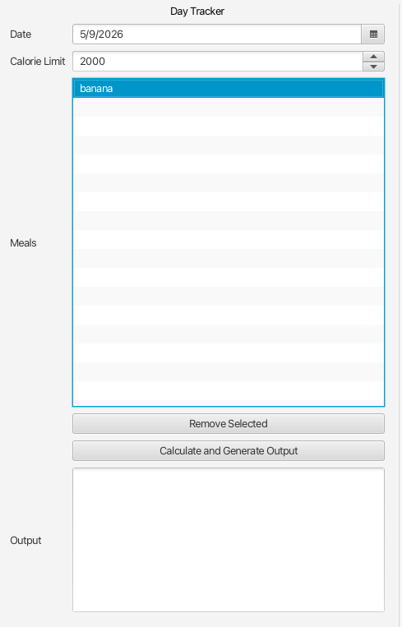

Result: Output is generated, top section header is updated
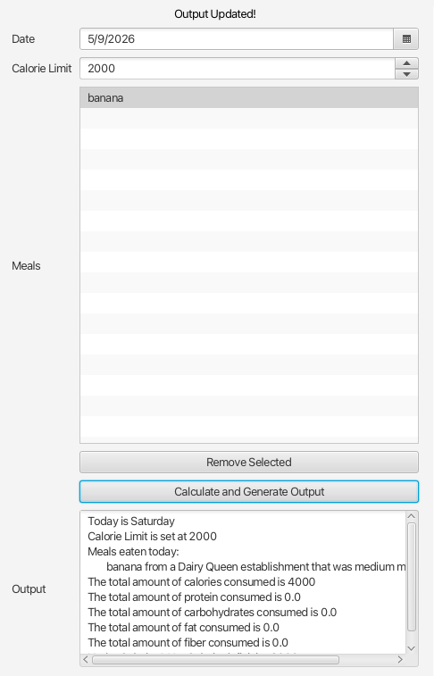

Testing Create New Meal form’s Is Fast Food Checkbox

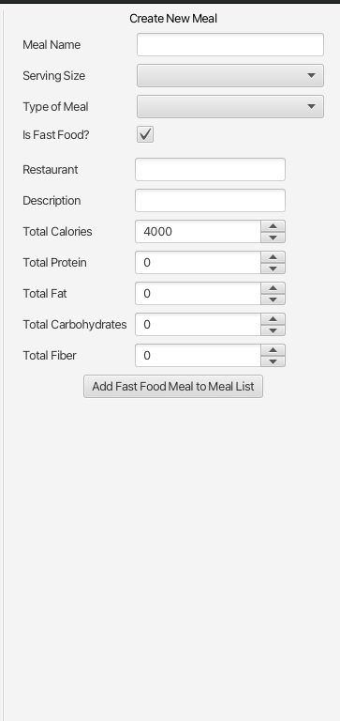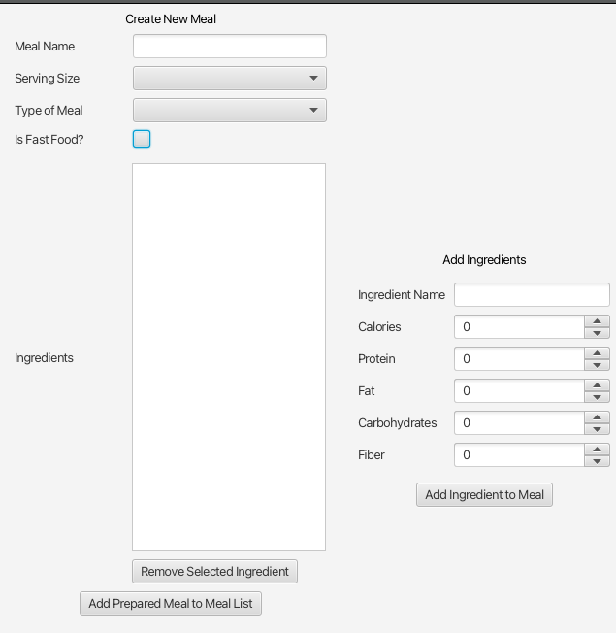
Result: form changes shape perfectly, with no Exceptions thrown

Attempting to submit new Fast Food item with various fields missing
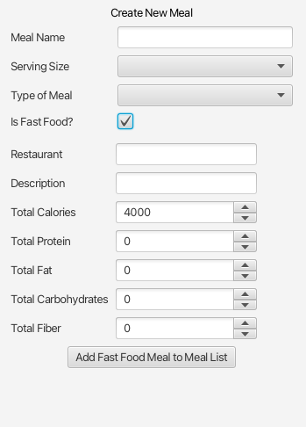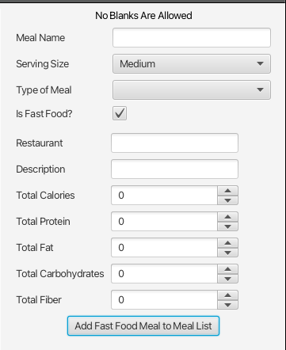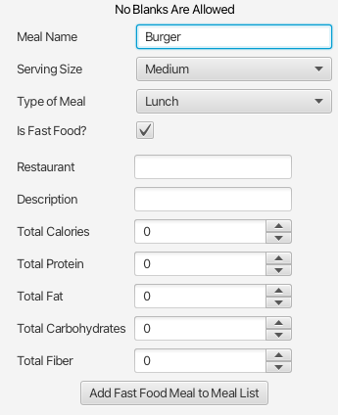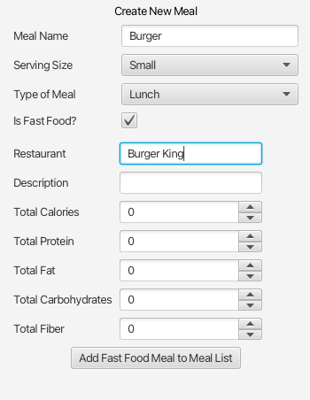

Result: All of these result in no Exception being thrown, and the top header for the second section being changed for all except missing Description, as Description is allowed to be blank. Numbers are allowed to be 0 as well:
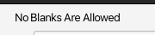

Attempt to place letter characters in spin boxes and change focus
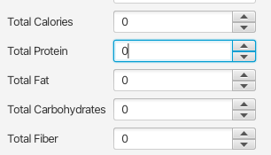
Result: No Exceptions are thrown and values do not change

Running Add Fast Food Meal to Meal List button with correct fields filled out
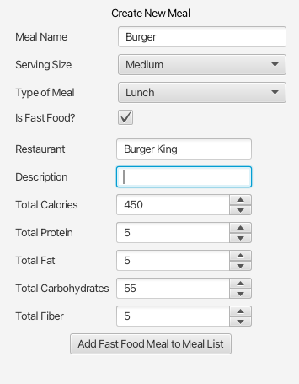

Result: Meal is added to listView on the left in the first section, with the name shown in listView
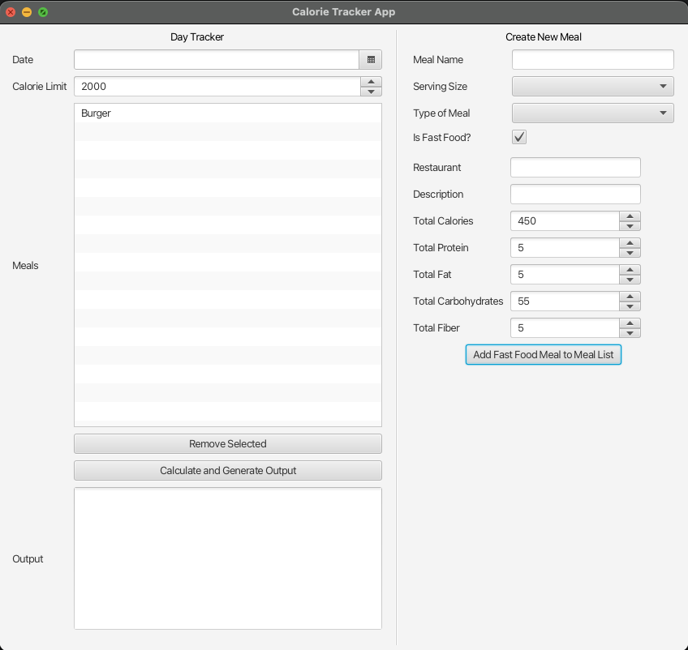

Trying to add a prepared meal with no meals in ingredients
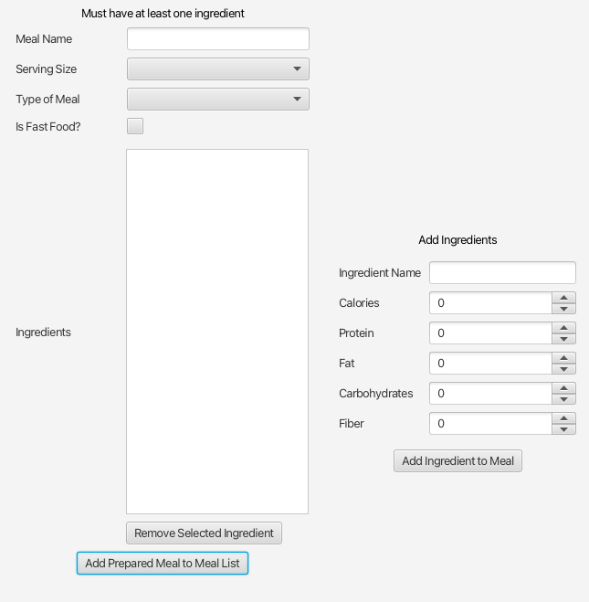

Result: No Exception is thrown, top header of section 2 is changed to read an error
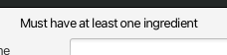

Trying to remove an ingredient without any ingredients
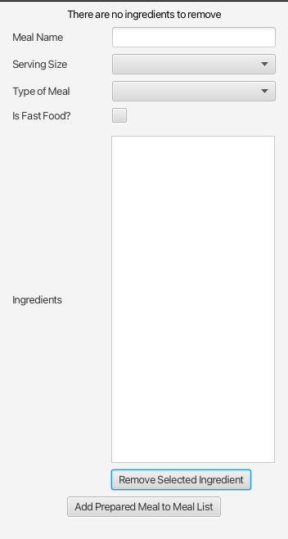

Result: No Exceptions are thrown, top section header is updated to show error

Attempting to remove an ingredient while there are ingredients in list but nothing is selected
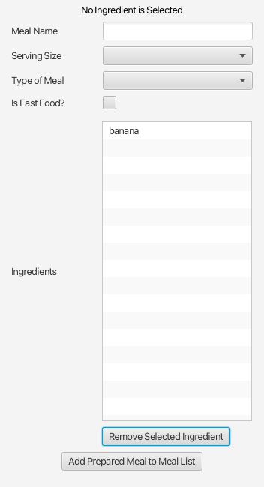
Result: No Exception is thrown, top header for the section is updated

Removing an ingredient with ingredients in the list and selected
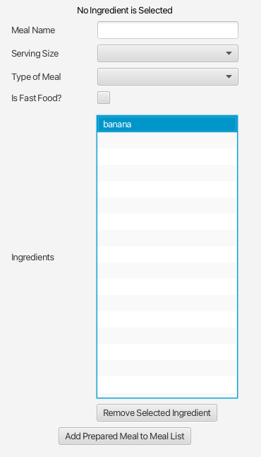

Result: Ingredient removed from list
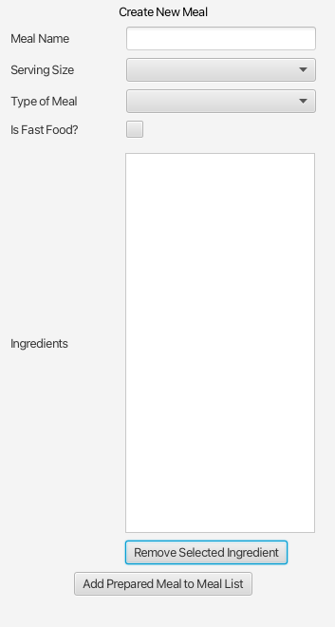

Attempt to add prepared Meal to Meal list with various fields missing
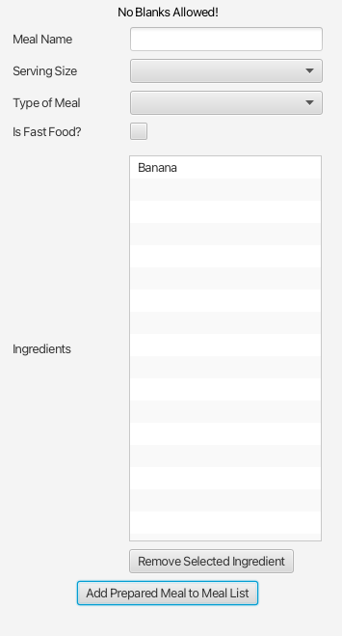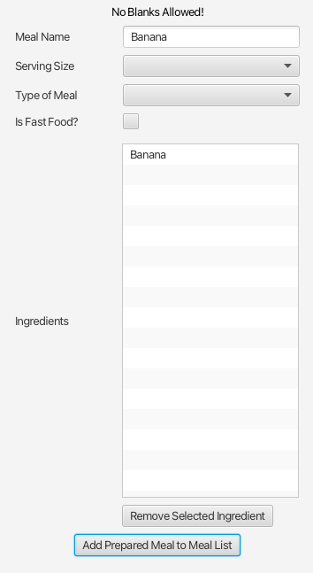
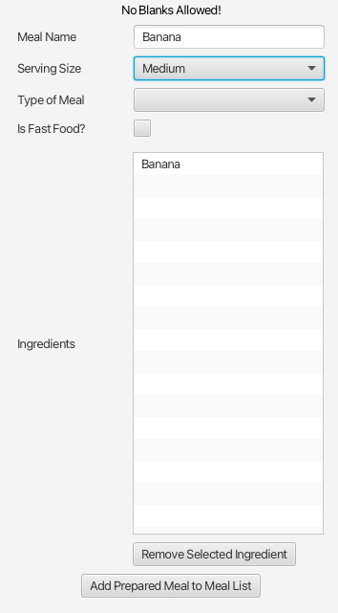
Result: No Exceptions are thrown and the top Section header is changed


Adding a Prepared Meal with all fields filled out correctly
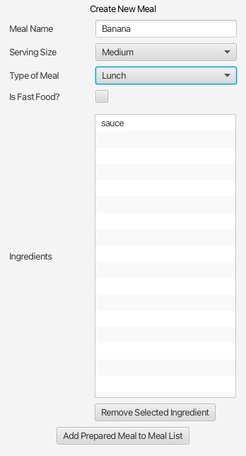
Result: No Exceptions thrown and Prepared Meal is added to the list in first pane, Meal form is cleared
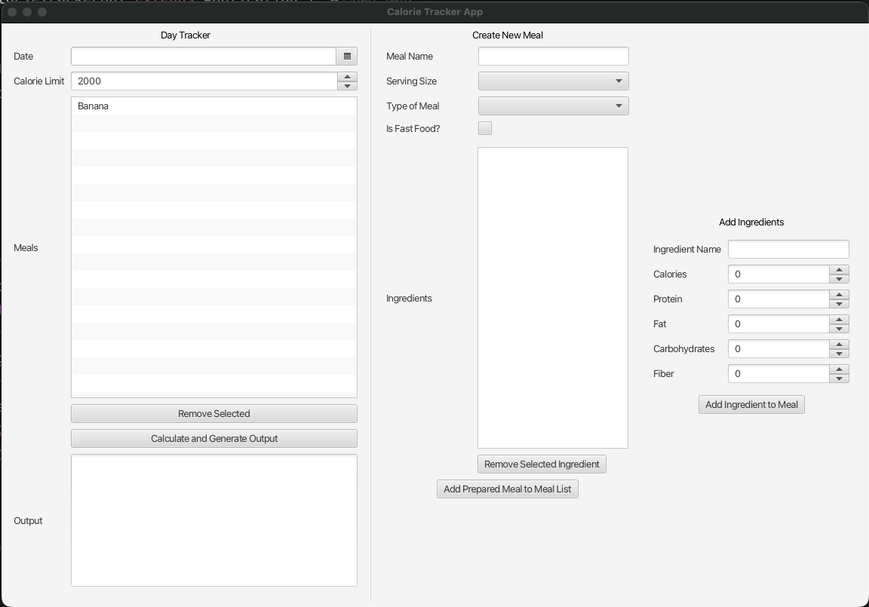

Attempt to add ingredient with no name
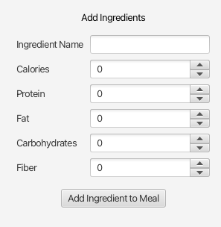
Result: No Exception is thrown, top section header is updated to show error
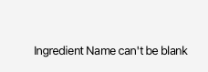

Attempt to type letter characters in spinners and change focus
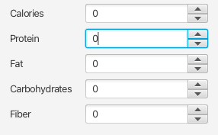

Add Ingredient to Meal
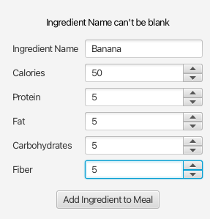

Result: Ingredient added to list view in second column, ingredients form is cleared
